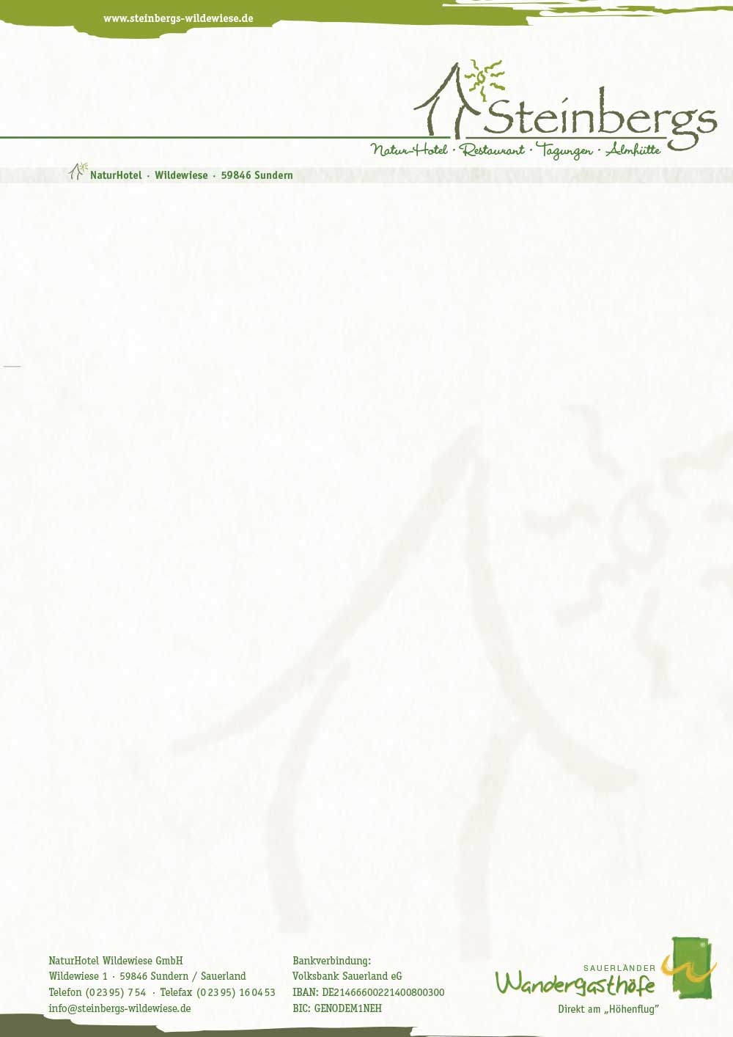

**Offer Christmas time & Turn oft he year**

(5 % early booking discount till 31.03.2018)

**Chrsitmas sent & fireworks 26.12.2018 – 01.01.2019 SR DR**

**(7 days/6nights) Standard 709 € 529 €**

6 dreamy nights **Comfort 769 € 589 €**

1 time Champagne menu **Comfort Plus 829 € 679 €**

1 time 4 course menu

1 time 4- course menu

1 time christmas buffet

1 time „goose delicious“ with accompanying Trollinger

1 time sauerländer buffet

elaborated hiking trails

1 guided hike with coffee & cake board

1 time New Year’s Eve with buffet

New Year’s brunch

5 times vital breakfast

Sauna use

cuddly bathrobe

A special week with Christmas spirit and start of the year 2019.

You arrive relaxed on **Wednesday**, the 2nd Christmas day.

In the evening we await you with a festive Christmas buffet in the SteinbergsAlm.

**Thursday** is all about the goose – whole goose and more in the SteinbergsAlm.

On **Friday** you will hike with the head of the house Franz Josef Steinberg through the Sauerland mountains,

afterwards we enjoy grandma Ursel’s Sauerland platen cake at a shared coffee table.

In the evening we spoil you with a 4-course menu.

On **Saturday** evening our Sauerländer buffet awaits you in the Steinbergs Alm.

Hiking on **Sunday** or just enjoying time – let the year pass by …

In the evening, the Steinbergs team will serve you a champagne menu.

**Monday** New Year – with a culinary buffet we end the year – afterwards

we celebrate together in the year 2019 or you make the turn of the year rather contemplative.

**Tuesday** cozy New Year’s brunch in the SteinbergsAlm also for late risers until 14 o’clock.

After a New Year’s hike, it’s off to home.