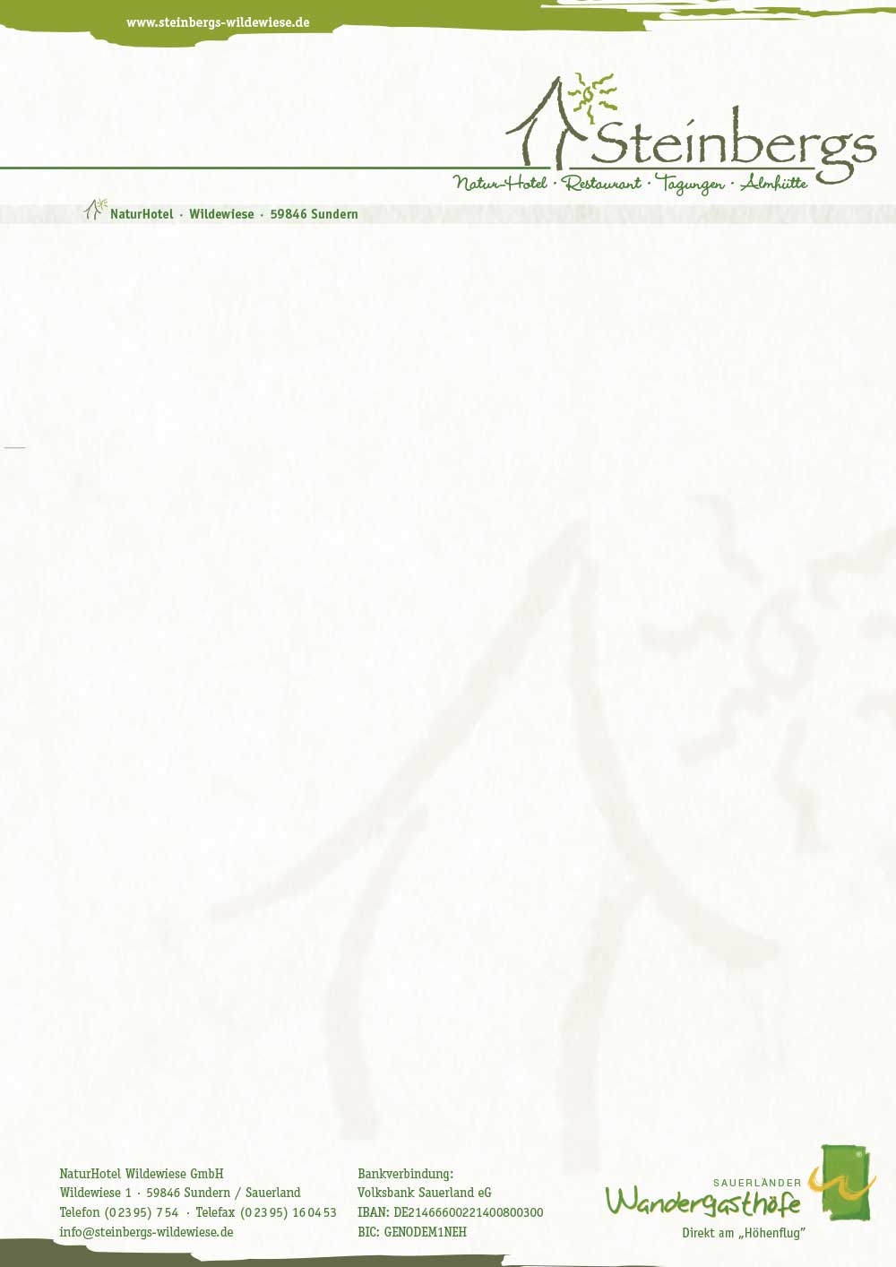

**New Year’s Eve offer**

**28.12.2018 – 01.01.2019 SR DR**

**(5 days/4 night) Standard 485 € 365 €**

4 dreamy nights **Comfort 565 € 425 €**

1 time Champagne menu **Comfort Plus 605 € 485 €**

1 time 4-course menu

1 time sour buffet

elaborated hiking trails

1 time together New Year’s Eve with buffet

New Year’s brunch

3 times vital breakfast

sauna use

cozy bathrobe

You arrive relaxed on **Friday**.

In the evening we spoil you with a 4-course menu.

On **Saturday** evening evening Sauerländer buffet in the Steinbergs Alm.

Hiking on **Sunday** or simply enjoying time – let the year pass by

In the evening, the Steinbergs team will serve you a champagne menu

**Monday** New Year – with a culinary buffet we end the year – afterwards

Let’s celebrate together in the year 2019 or you make the turn of the year rather contemplative.

**Tuesday** cozy New Year’s brunch in the SteinbergsAlm also for late risers until 14 clock J

After a New Year’s hike, it’s on the way home.

